Name: ____________
Pennsylvania History
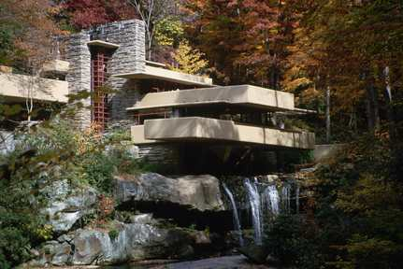
Corbis, (2006). Exterior of Fallingwater by Frank Lloyd Wright. [Image]. Available from http://www.discoveryeducation.com/

Why might a city dweller enjoy this house? Imagine being on one of the balconies. What would you hear?
_______________________________________
_________________________________________________________________________________________________________________________________________________________________________________________________________________________________________________________________________________________________________________________________________________________________________________________________________________________________________________________________________________________________________________________________________________________________________________________________________

